**Practical 10 (Content Provider)**

**Question 1**

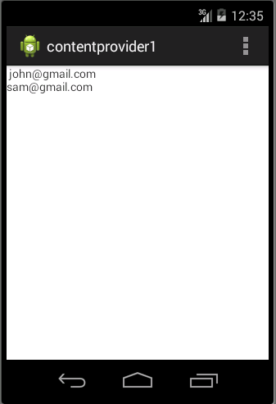

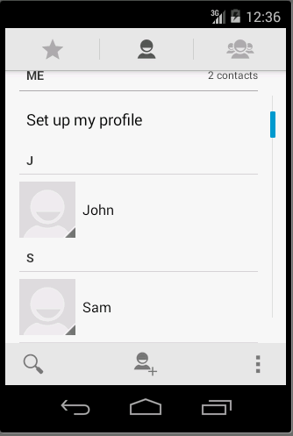

1. Your **activity_main.xml** file should have something similar to xml below: **(p/s: You do not need to follow the xml as it might be different in each design.)**

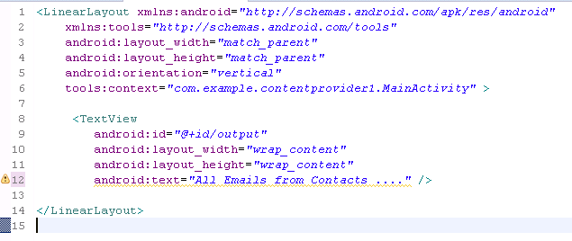

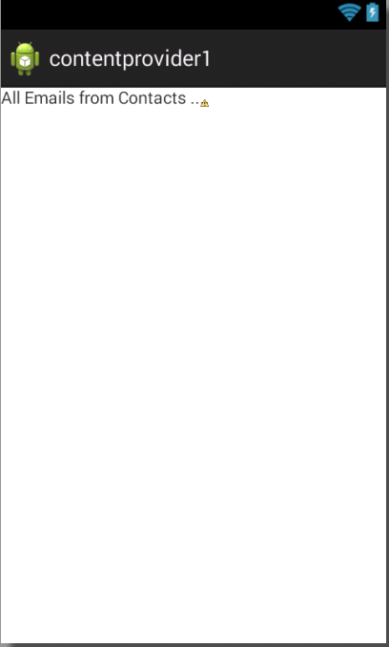

1. In your **MainActivity.java**, code the following code segment.

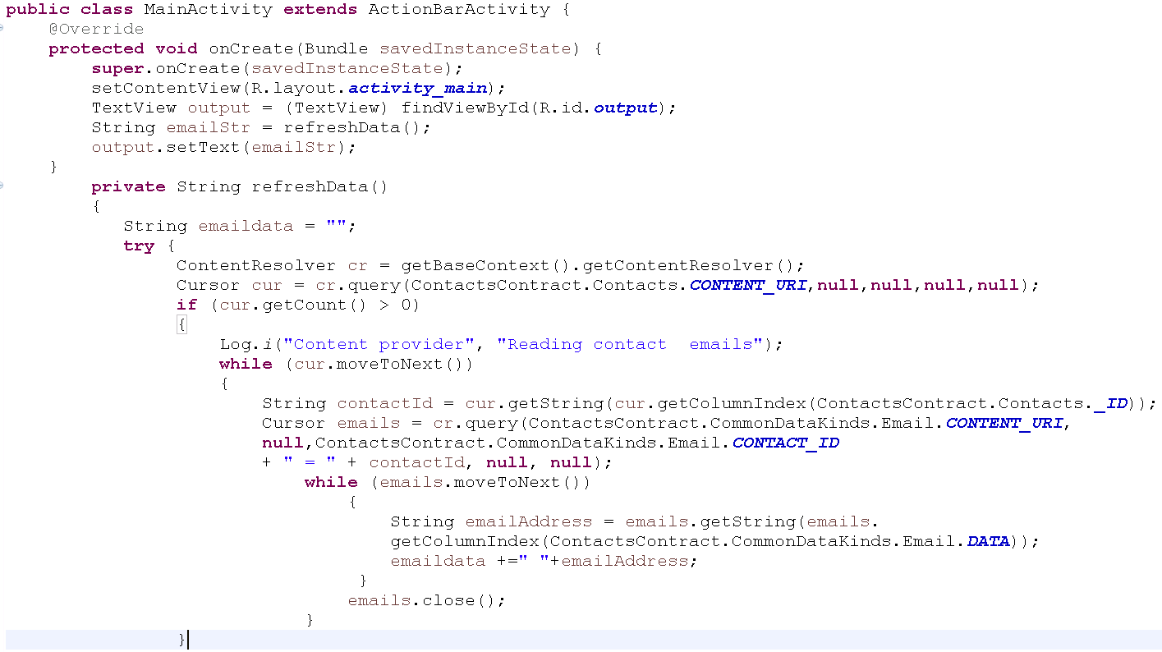

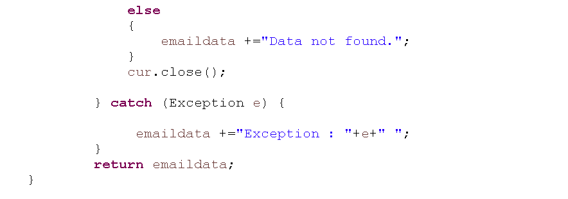

1. After make sure all the coding appropriate done, you may compile and run your coding .

**Question 2**

1. In this question, you are required to create an app with the following interface.

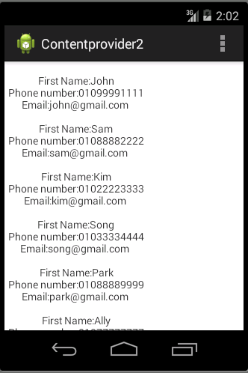

1. Based on the understanding from question 1, you should create an app to retrieve all the contact’s in your phonebook. You should get the data and keep it as a LIST in the app as shown above.

**Question 3(CalendarContact)**

1. In this question, you are required to create an app with the following interface.

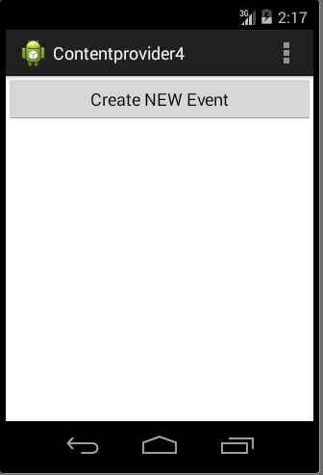

1. In your **MainActivity.java**, code the following code segment.

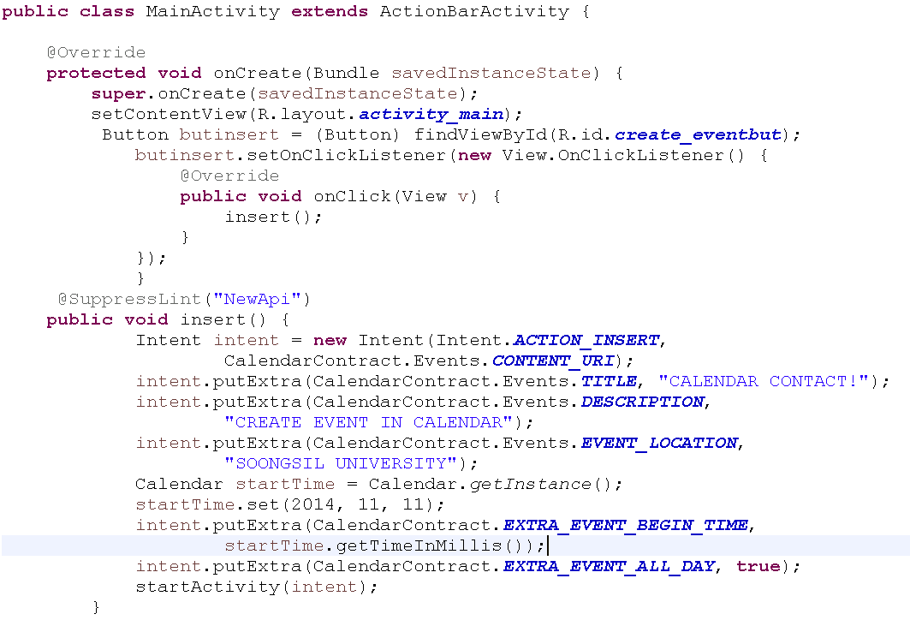

1. After make sure all the coding appropriate done, you may compile and run your coding .
2. Make sure you provide the necessary permission in AndroidManifest.

**Question 4(File)**

1. In this question, you are required to create an app with the following interface.

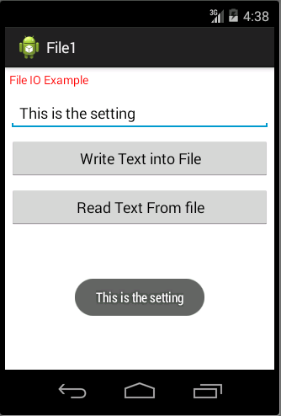

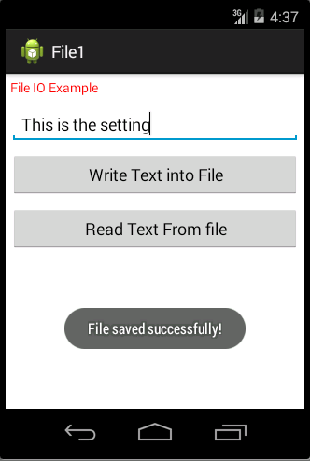

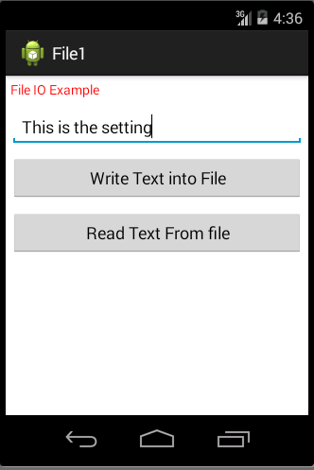

1. In your **MainActivity.java**, code the following code segment to provide function to the button created in activity_main.xml.

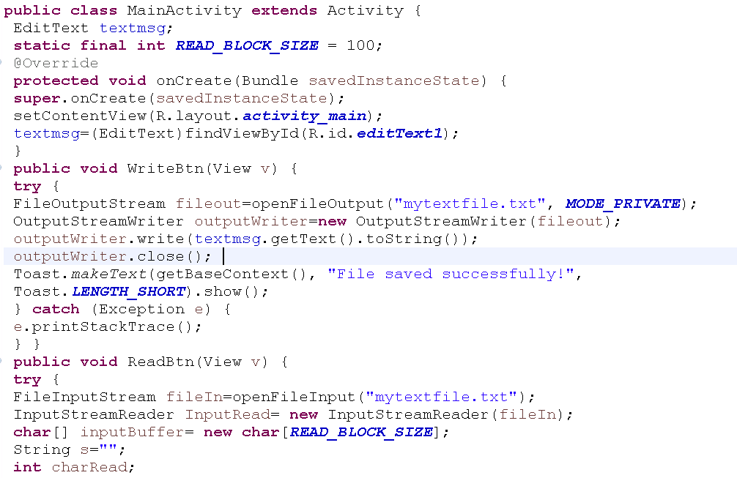

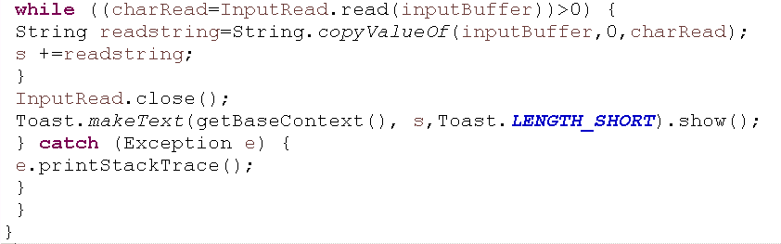

1. After make sure all the coding appropriate done, you may compile and run your coding .

**Question 5(File)**

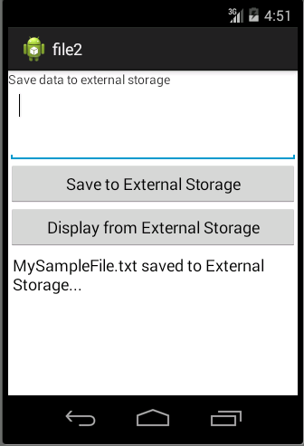

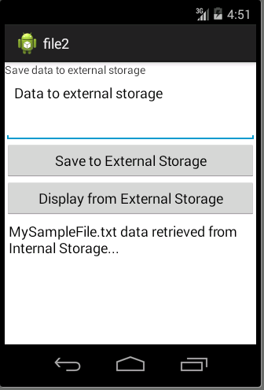

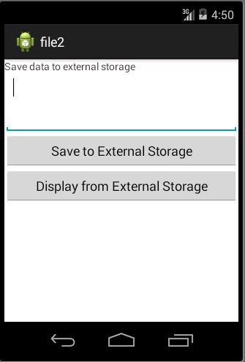

1. In this question, you are required to create an app with the following interface.
2. When user click on the first button, the data entered should be save to external storage.
3. When the user click on the second button, the data from external storage should be loaded and display on the edittext.